Lagged cross-correlation: EURUSD and USDCHF
Method 12 / daily log returns / K_max=10 / Alpari D1 full available history

Study setup
Logical pair: EURUSD , USDCHF
Broker symbols: EURUSD_i , USDCHF_i
Snapshot: 2026-11-03_majors_alpari_D1
Timeframe: D1
Matched return window: 1999-01-05 to 2026-11-02 (UTC bar dates)
Matched return count n: 7186
Dropped unfinished last bar dated 2026-11-03 UTC after a tick-volume check against the prior complete day.
Lag definition: rho_X->Y(k) = Corr(x_t, y_{t+k}) on matched D1 bars
K_max = 10; headline lag k = 1 (both directions)
Complete matched rows (Excel): EURUSD-USDCHF_Lagged_D1.xlsx
Complete matched rows (HTML table): EURUSD-USDCHF_Lagged_D1_data.html

Method carried forward
Lagged cross-correlation measures Pearson correlation between matched daily log returns of close, ln(close_t / close_t-1), after shifting one series forward by k bars on the matched panel. Quotes are not inverted. rho_{X->Y}(k) = Corr(x_t, y_{t+k}) with n_k = n - k. K_max = 10 is fixed before estimation. The headline is the pre-specified lag k = 1 in both directions. k = 0 is the same-bar side check. The lag inside 1..10 with the largest absolute rho is stored as a descriptive column only; it is not a selected result. This is a linear screen, not proof of forecast edge, economic cause, or a trading signal.

Results (headline k=1)
rho_EURUSD->USDCHF(1): 0.013360 (n=7185)
95% Fisher interval EURUSD->USDCHF: [-0.009767, 0.036471]
rho_USDCHF->EURUSD(1): 0.035522 (n=7185)
95% Fisher interval USDCHF->EURUSD: [0.012409, 0.058597]
Same-bar rho(k=0): -0.749204
Largest |rho| among k=1..10 (descriptive only, not selected): EURUSD->USDCHF k=8 rho=-0.031244; USDCHF->EURUSD k=1 rho=0.035522

CCF table
k | rho_EURUSD_to_USDCHF | n_EURUSD_to_USDCHF | rho_USDCHF_to_EURUSD | n_USDCHF_to_EURUSD
0 | -0.74920352 | 7186 | -0.74920352 | 7186
1 | 0.01335954 | 7185 | 0.03552162 | 7185
2 | -0.01039946 | 7184 | -0.00958695 | 7184
3 | 0.00870563 | 7183 | 0.00625923 | 7183
4 | -0.0130386 | 7182 | -0.00186955 | 7182
5 | -0.02504478 | 7181 | 0.01727235 | 7181
6 | 0.00357543 | 7180 | 0.0108586 | 7180
7 | 0.00393347 | 7179 | -0.01066033 | 7179
8 | -0.03124408 | 7178 | -0.01701305 | 7178
9 | 0.02687623 | 7177 | 0.02386123 | 7177
10 | 0.00199383 | 7176 | -0.00013751 | 7176

Conclusion
At the pre-specified lag k=1 for EURUSD and USDCHF, rho_{EURUSD->USDCHF}(1) = 0.0134 (n=7185) and rho_{USDCHF->EURUSD}(1) = 0.0355 (n=7185). Same-bar rho(k=0) = -0.7492. Largest |rho| among k=1..10 is descriptive only: EURUSD->USDCHF at k=8 (-0.0312); USDCHF->EURUSD at k=1 (0.0355). This is a linear screen, not forecast proof or a trading signal.

Charts
Daily closes

Daily log returns

CCF both directions k=0..10
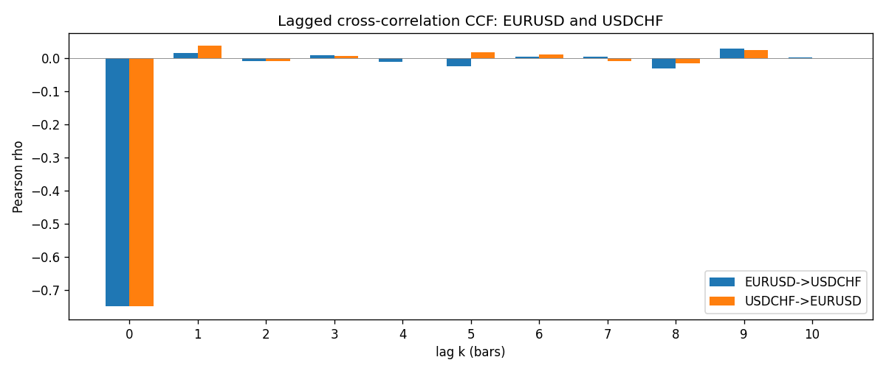

Data report
Every matched row is stored in the sibling Excel workbook named EURUSD-USDCHF_Lagged_D1.xlsx (sheet matched_rows). The CCF sheet holds rho(k) for k=0..10. Embedding all rows as a Word table is impractical; the Word file holds column summaries and the first and last 15 rows.
Columns: time, EURUSD_open, USDCHF_open, EURUSD_high, USDCHF_high, EURUSD_low, USDCHF_low, EURUSD_close, USDCHF_close, EURUSD_tick_volume, USDCHF_tick_volume, EURUSD_spread, USDCHF_spread, EURUSD_real_volume, USDCHF_real_volume, EURUSD_log_return, USDCHF_log_return
Column summaries (matched calculation rows)
column | count | mean | std | min | 25% | 50% | 75% | max
EURUSD_open | 7186 | 1.181536 | 0.15083018 | 0.8272 | 1.086205 | 1.16621 | 1.29401 | 1.5995
USDCHF_open | 7186 | 1.0974503 | 0.25221737 | 0.72022 | 0.9205325 | 0.9899 | 1.23765 | 1.8219
EURUSD_high | 7186 | 1.1866696 | 0.15143104 | 0.8326 | 1.090285 | 1.17131 | 1.299445 | 1.6038
USDCHF_high | 7186 | 1.102742 | 0.25396197 | 0.73305 | 0.924775 | 0.99353 | 1.2422 | 1.8313
EURUSD_low | 7186 | 1.1765242 | 0.15015364 | 0.8227 | 1.0820725 | 1.16258 | 1.2885325 | 1.5865
USDCHF_low | 7186 | 1.0923313 | 0.25063382 | 0.08565 | 0.91721 | 0.98623 | 1.2315 | 1.8121
EURUSD_close | 7186 | 1.1815785 | 0.15080545 | 0.8267 | 1.0860875 | 1.166185 | 1.2941 | 1.5997
USDCHF_close | 7186 | 1.0974447 | 0.25212504 | 0.72025 | 0.920795 | 0.98995 | 1.237525 | 1.8217
EURUSD_tick_volume | 7186 | 103207.57 | 173534.06 | 218 | 9426 | 52774.5 | 99579.75 | 1471626
USDCHF_tick_volume | 7186 | 74325.102 | 113489.5 | 18 | 12800 | 40232.5 | 70435.25 | 858589
EURUSD_spread | 7186 | 19.339549 | 16.550572 | 0 | 8 | 12 | 20 | 50
USDCHF_spread | 7186 | 26.036877 | 24.695014 | 0 | 5 | 16 | 50 | 100
EURUSD_real_volume | 7186 | 4.0330482e+10 | 1.6691688e+11 | 0 | 0 | 0 | 0 | 3.6149665e+12
USDCHF_real_volume | 7186 | 2.3290849e+10 | 8.9127816e+10 | 0 | 0 | 0 | 0 | 1.9331921e+12
EURUSD_log_return | 7186 | -3.06e-06 | 0.00580427 | -0.03123819 | -0.00324267 | 0 | 0.00325778 | 0.03433183
USDCHF_log_return | 7186 | -6.921e-05 | 0.00659379 | -0.19545699 | -0.00335085 | 8.077e-05 | 0.003323 | 0.09051364
First 15 matched rows (selected columns)
time | EURUSD_close | USDCHF_close | EURUSD_log_return | USDCHF_log_return
1999-01-05 | 1.1758 | 1.3724 | -0.0048360507 | 0.0039424743
1999-01-06 | 1.1623 | 1.3912 | -0.011547966 | 0.013605652
1999-01-07 | 1.1712 | 1.3782 | 0.0076280636 | -0.0093883841
1999-01-08 | 1.1585 | 1.3935 | -0.010902799 | 0.011040268
1999-01-11 | 1.1503 | 1.4009 | -0.007103287 | 0.0052963193
1999-01-12 | 1.1555 | 1.3872 | 0.0045103728 | -0.0098275602
1999-01-13 | 1.1681 | 1.3621 | 0.010845346 | -0.018259701
1999-01-14 | 1.1681 | 1.3588 | 0 | -0.0024256692
1999-01-15 | 1.1563 | 1.3834 | -0.010153245 | 0.01794228
1999-01-18 | 1.1605 | 1.379 | 0.0036256946 | -0.0031856384
1999-01-19 | 1.1603 | 1.3789 | -0.00017235436 | -7.2518946e-05
1999-01-20 | 1.1566 | 1.3889 | -0.0031939256 | 0.0072259871
1999-01-21 | 1.1601 | 1.3836 | 0.0030215416 | -0.0038232689
1999-01-22 | 1.1587 | 1.3834 | -0.0012075213 | -0.0001445609
1999-01-25 | 1.1552 | 1.3868 | -0.0030251979 | 0.0024546976
Last 15 matched rows (selected columns)
time | EURUSD_close | USDCHF_close | EURUSD_log_return | USDCHF_log_return
2026-10-13 | 1.11965 | 0.83244 | 0.0037402957 | -0.0024955621
2026-10-14 | 1.11545 | 0.83489 | -0.0037582255 | 0.0029388325
2026-10-15 | 1.12172 | 0.82676 | 0.0056053107 | -0.0097855323
2026-10-16 | 1.12371 | 0.82377 | 0.0017724895 | -0.0036230826
2026-10-19 | 1.12086 | 0.82677 | -0.0025394633 | 0.0036351779
2026-10-20 | 1.12354 | 0.8246 | 0.0023881672 | -0.0026281224
2026-10-21 | 1.12318 | 0.82427 | -0.00032046717 | -0.00040027413
2026-10-22 | 1.12139 | 0.82032 | -0.0015949606 | -0.0048036381
2026-10-23 | 1.11989 | 0.82497 | -0.001338521 | 0.005652514
2026-10-26 | 1.11735 | 0.82649 | -0.0022706559 | 0.0018407959
2026-10-27 | 1.11272 | 0.82865 | -0.004152342 | 0.0026100526
2026-10-28 | 1.1152 | 0.82781 | 0.0022262927 | -0.0010142111
2026-10-29 | 1.11772 | 0.82379 | 0.0022571351 | -0.0048680164
2026-10-30 | 1.11644 | 0.82438 | -0.0011458446 | 0.00071594559
2026-11-02 | 1.11881 | 0.81851 | 0.002120569 | -0.0071459744

